

SCHOOL OF MECHANICAL & MANUFACTURING ENGINERRING

NUST

Department of Mechanical Engineering

CS-114 – Fundamentals of Programming

LAB MANUAL #08

**Course Instructor**: Dr Khawaja Fahd Iqbal

**Lab Instructor**: Muhammad Affan

**Student Name**: Muhammad Usman Abdullah

**Section**: B

**CMS ID**: 461513

**DATE**: 06-December-2023

LAB #08 (LAB TASK)

TASK 1:

#include<iostream>

using namespace std;

int main() {

int n;

cout << "Enter the size of the array: ";

cin >> n;

int arr[n];

cout << "Enter the elements of the array: ";

for(int i = 0; i < n; i++) {

cin >> arr[i];

}

int max_count = 0, max_element = -1;

for(int i = 0; i < n; i++) {

int count = 0;

for(int j = 0; j < n; j++) {

if(arr[i] == arr[j]) {

count++;

}

}

if(count > max_count) {

max_count = count;

max_element = arr[i];

}

}

cout << "The most repeated element is: " << max_element << endl;

return 0;

}

OUTPUT:

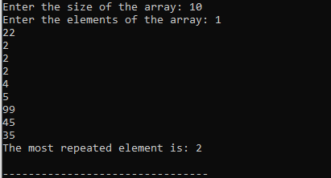

TASK 2:

#include<iostream>

using namespace std;

int main() {

int arr[8]={13,15,17,9,99,77,65,43};

int max_element = arr[0], min_element = arr[0];

for(int i = 1; i < 8; i++) {

if(arr[i] > max_element) {

max_element = arr[i];

}

if(arr[i] < min_element) {

min_element = arr[i];

}

}

cout << "The largest element is: " << max_element << endl;

cout << "The smallest element is: " << min_element << endl;

return 0;

}

OUTPUT:



TASK 3:

#include<iostream>

using namespace std;

int main() {

int arr[5];

cout << "Enter the elements of the array: "<<endl;

for(int i = 0; i < 5; i++) {

cin >> arr[i];

}

int temp = arr[2];

arr[2] = arr[4];

arr[4] = temp;

cout << "The elements of the array after swapping are: ";

for(int i = 0; i < 5; i++) {

cout << arr[i] << " ";

}

return 0;

}

OUTPUT:

